Aline Coelho Sanches Corato

Federal University of Sergipe

**Reidy, Affonso Eduardo (1909-1964)**

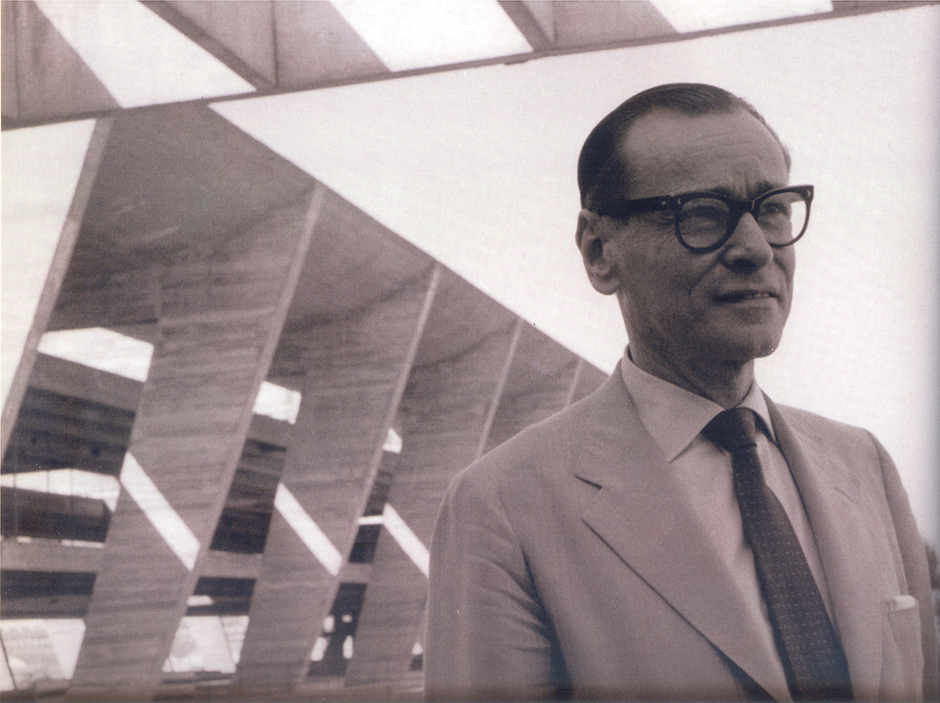

Affonso Eduardo Reidy

Published in Bonduki, N. G. (ed.) (1999) *Affonso Eduardo Reidy*, São Paulo: Instituto Lina Bo e P. M. Bardi; Lisboa: Blau / Copyright: Carmen Portinho Archives

The Brazilian architect and town planner Affonso Eduardo Reidy was born in Paris and studied architecture at the National School of Fine Arts of Rio de Janeiro (1926-30). Its newly appointed director, Lucio Costa, sought progressive teachers to join the faculty in an attempt to reform the school in a Modernist direction. At Costa’s invitation, Reidy became an assistant lecturer upon his graduation in 1931. Reidy was also a trainee and assistant (1929-1931) of Alfred Agache, the French town planner at the time responsible for the master plan of Rio de Janeiro. Reidy became an architect of the city council in 1932 (Brazil’s capital at that time) and began his thirty-year career in architectural design and planning that helped define Brazilian Modern architecture.

Alongside the architect Gerson Pompeu Pinheiro, Reidy was responsible for one of Rio’s first Modernist buildings, the Albergue da Boa Vontade (1931-32). He participated in designing the Ministry of Education and Health (1936), which became a key work of Brazilian Modern architecture. To have worked on this project under the direction of Le Corbusier was a pivotal experience for the young architect.

Reidy’s designs for Rio de Janeiro expressed his own Modernist vision of town planning. This is noticeable in his most noted project, Pedregulho (Conjunto Residencial Prefeito Mendes de Moraes, 1946), and in the partially constructed Marquês de São Vicente (1952), which were both projects of the City’s Department of Popular Housing under the direction of the engineer, and his partner, Carmen Portinho. Pedregulho was a prize-winner at São Paulo’s Second Biennial (1953) and highly praised by international critics. His projects were seen as combining the so-called social function of architecture with aspects of Brazilian Modern architecture such as the use of the curve, lightness, structural boldness, a seamless relationship between the building and the landscape and an emphasis on the integration of the arts within architecture.

Reidy’s 1952 Experimental School in Asuncion, Paraguay, pioneered the local use of exposed concrete. This design was a precursor of his famous Museum of Modern Art in Rio de Janeiro (1953), which exemplified Reidy’s lifelong pursue of integrating his buildings within the surrounding landscape.

In 1962, Reidy was asked to resume parts of his unrealised 1948 plan for the centre of Rio de Janeiro as part of the group responsible for the design and construction of Aterro Glória-Flamengo (Flamengo Park). In this final project in Reidy’s career, he was responsible for the park’s design and for the design of its bandstand, dance floor, playgrounds and walkway.

**List of Works**

1936 Ministry of Education and Health, Rio de Janeiro, Brazil (with Lucio Costa, Carlos Leão, Jorge Moreira, Ernani Vasconcellos, Oscar Niemeyer, and Le Corbusier consulting. Landscape design by Roberto Burle Marx).

1946 Pedregulho (Conjunto Residencial Prefeito Mendes de Moraes), Rio de Janeiro, Brazil

1950 Carmen Portinho Residence, Rio de Janeiro, Brazil

1953 Museum of Modern Art in Rio de Janeiro, Brazil

1962-4 Aterro Glória-Flamengo (*Flamengo Park*), Rio de Janeiro, Brazil

**References and further Reading**

Franck, K. (texts) and Giedion, S. (introduction) (1960) *The works of Affonso Eduardo Reidy*, New York: Frederick A. Praeger, Publishers.

Solar Grandjean de Montigny (1985) *Affonso Eduardo Reidy*, Rio de Janeiro: O solar/ Index.

Bonduki, N. G. (ed.) (1999) *Affonso Eduardo Reidy*, São Paulo: Instituto Lina Bo e P. M. Bardi; Lisboa: Blau.

**Visual material:**

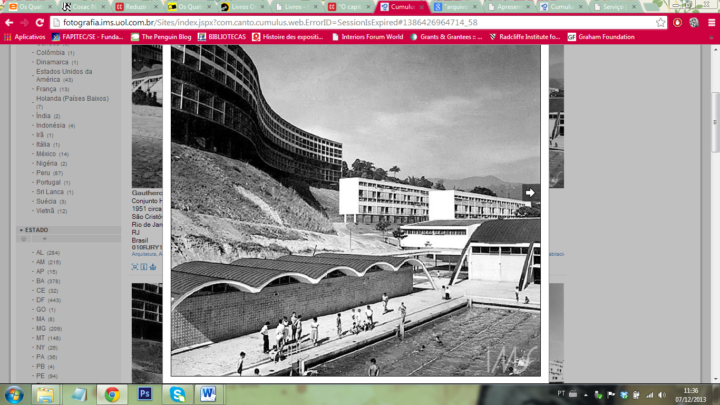

Pedregulho Residential Neihgborhood, Rio de Janeiro, 1946

Copyright: Instituto Moreira Salles - 010RJRY10434.jpg

<http://fotografia.ims.uol.com.br/Sites/index.jspx?com.canto.cumulus.web.ErrorID=SessionIsExpired#1386943625976_1>

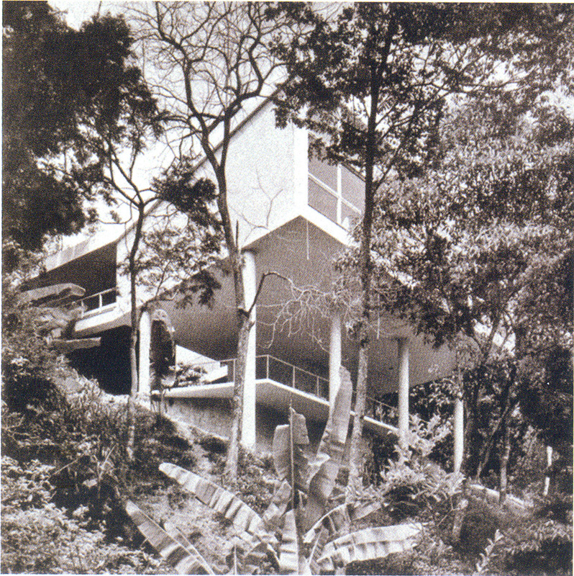

Residence for Carmen Portinho in Jacarepaguá, Rio de Janeiro, 1950

Published in Bonduki, N. G. (ed.) (1999) *Affonso Eduardo Reidy*, São Paulo: Instituto Lina Bo e P. M. Bardi; Lisboa: Blau / Copyright: Carmen Portinho Archives

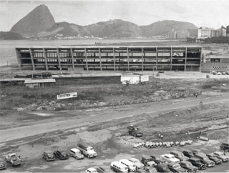

Museum of Modern Art, under construction, Rio de Janeiro, 1953

Copyright: Museu de Arte Moderna do Rio de Janeiro – Centro de memória MAM/RJ

<http://mamrio.org.br/wp-content/uploads/2012/11/a004.jpg>

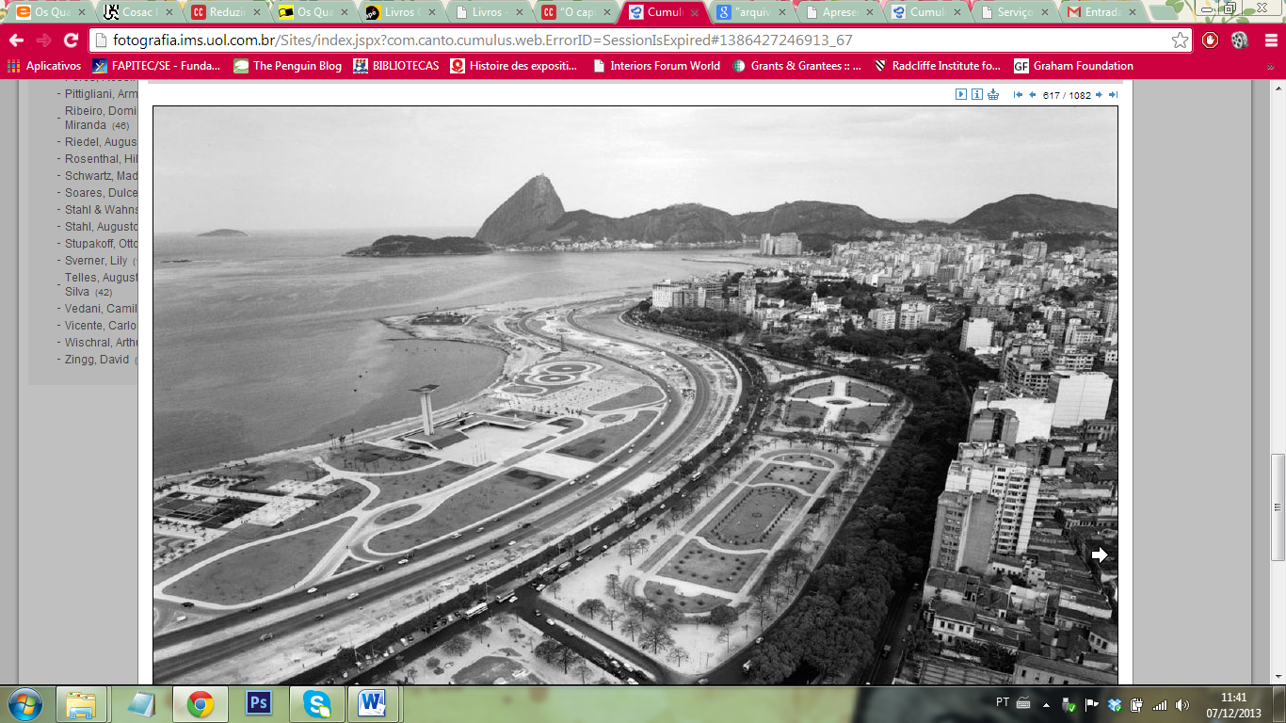

Aterro Glória-Flamengo (Flamengo Park), Rio de Janeiro, Brazil

Copyright: Instituto Moreira Salles - 010RJAT26188.tif

<http://fotografia.ims.uol.com.br/Sites/index.jspx?com.canto.cumulus.web.ErrorID=SessionIsExpired#1386943934865_5>